1. **Requirement**: In the previous lecture, we created directive, which changes the background colour of the element on which it resides. But that colour is always orange.   
    Now, we want to let user specify the colour (parameter to directive).
2. 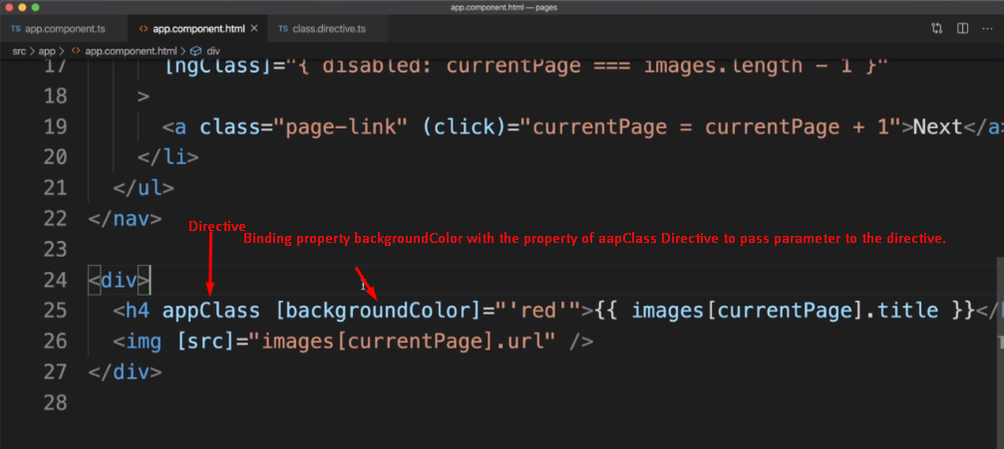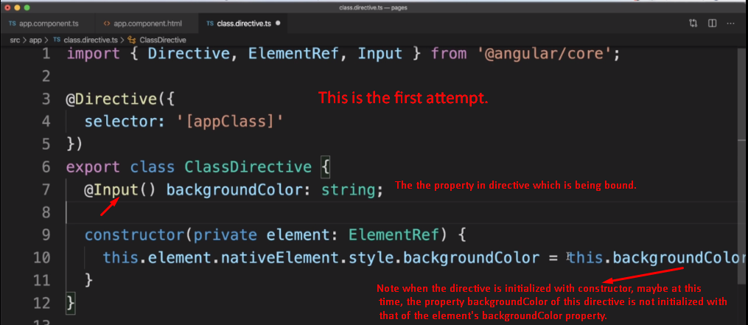
3. z